Title of Paper
Author^{1*}, Author¹ and Author¹

¹ Programa de Engenharia Ambiental, UFRJ, Universidade Federal do Rio de Janeiro, Rio de Janeiro, 21941-901, Brazil.

xxx@poli.ufrj.br; xxx@poli.ufrj.br; xxx@poli.ufrj.br
* Corresponding author

Abstract:
This template provides detailed instructions for preparing and submitting a paper to the 6th Workshop on Environmental Engineering. Please follow these instructions: a) type the body of the paper in a single column; b) use 2 to 3 A4-size pages (21 cm x 29.7 cm), each formatted with 2.5 cm margins on all sides except at the top of the page (do not print any border around the text and do not insert page numbers); c) use 12 pt Times New Roman throughout the text; d) type up to 200 words in the abstract, in italics; e) always use single-spaced lines, justified alignment; f) supply good quality figures/photographs being recommended a resolution of 300 dpi (color figures can be used); g) define all symbols as they appear in the text; h) use only SI units. The paper may be written in English. A good abstract should give a brief overview of the paper, including the background and/or rationale, the research methodology, and the findings from the research. It is also a good practice to explain how the study's conclusions help solve problems or minimize gaps in the specific area/field/community/industry. The abstract should not have in-text citations.
Keywords:
Up to 5 keywords should be provided alphabetically, separated by commas.

Introduction
This document can be used as a template for your paper by applying the styles given. Your full document should have 2 to 3 pages, including the References section, and consist of at least the following components: an Abstract, an Introduction, Research Methodology, and References. The introduction section should provide an overview of the research as well as the background and context of the paper. Starting from general to give the 'big picture' and moving down to specifics, this section should provide a rationale that justifies the research, i.e., why there is a necessity to conduct research on this subject. This can be done by providing evidence of problems that need solutions and/or an identified knowledge gap in a specific domain, level, geographical location, society, sector, industry, and so on, supported by key references. As a response, a clear research agenda can be described specifying the research aim and objectives to clarify the purpose of conducting the investigation.
The introduction should also not outline the structure of the paper, as the contents are self-evident in the article. Paper structure, section headings, and sub-headings in this template only serve as a guide. These align more with empirically based research. This Workshop notes that it is not possible for every paper to follow this guide, as some papers are systematic literature reviews, case studies, and action research, among others. Nevertheless, the authors must explain how the research was undertaken to attain the set aim and objectives in the paper. The explanation must highlight the research design, collection of data, and analytical methods adopted or to be adopted in the research.

Research Methodology
The research methodology section must elucidate the approach and/or the research design, data collection, and data analysis methods utilized in the research in such detail that they may be replicated. The suitability of the selected methodology over other options/alternatives should be justified with an academic basis.
In the event samples are used, the study population must be defined; the method of selecting the sample and the response rate should be stated as should any attempt to establish if the sample or response is biased. Before submission, all statistical or other quantitative analyses must be checked carefully for applicability and accuracy.
Some papers present very early stages of the research. This should not prevent the author from discussing potential research methodology that can be adapted based on the nature of the research problems/questions identified or the type of data expected at this stage. Research is iterative in nature, and researchers continuously modify their research methodology in light of new information and changes in circumstances.

Additional Information
The following style should be applied in writing the 6th Workshop on Environmental Engineering paper: (Perera, 2022) or (Jin; Osei-Kyei, 2021; Hassan; Feng, 2020) or (Hardie et al., 2019; Senaratne et al., 2018). Please note that for more than three authors, only the first author's surname appears, followed by "et al." in italic, a comma, one space, and then the year of publication. In the case of more than one article referenced, as shown in the above example, a semi-colon (;) must be added in between, followed by one space.
References must be listed in alphabetical order at the end of the paper. In each reference, indent all lines 0.75 cm except the first line, which starts directly at the left margin. Each reference must be cited in the text. The section REFERENCES presents an example of a reference list, including a journal article, a report, an edited book, proceedings, a dissertation, and a book.

Nesting Sub-sections
Starting from section 2 onwards (except for the References section), nesting sub-sections can be added whenever necessary by selecting "A22 Heading 2" or "A22 Heading 3" as appropriate.

The Level of Sub-section Nesting
Authors are not advised to use more than three levels of sub-section nesting. Using too many nesting levels will reduce clarity and confuse your article's readers.

Findings and Discussion
The authors should discuss all the findings from conducting the investigation so far. Even for the early stages of research (e.g., the paper may only aim to report an initial literature study), what has been synthesized from the literature should be discussed. This may be done by highlighting the similarities and/or differences from a variety of literature sources on the issues being investigated and the contextual nature of the similarities/differences (such as geographical locations, culture, or many other factors that may influence the discussion in those different literature sources).
In the case of papers reporting further stages of research, findings from the investigation should be clearly presented, followed by an analytical discussion of the results. This can be done, for instance, by critically demonstrating how the findings relate to the current body of knowledge in or relevant to the field of investigation. For papers reporting a completed investigation (or very close to completion), the authors should offer recommendations (for improvement) based on the data analysis and discussion of the findings. This section represents one of the most essential parts of the discussion, which presents the paper's main contributions.
Tables, figures, and equations can be used to better explain the findings. All tables, figures, and equations must be cited in the body of the paper appropriately. All tables should be left-aligned with the table caption numbered and placed above the table, as shown below. Do not use font sizes smaller than Times New Roman 10 pt for text in tables.
Table 1. The occurrence of the decision resulted from a two-decision-makers condition.
 | R¹ | R² | R³ | R⁴ | R⁵ | R⁶ | R⁷ | R⁸ | R⁹
L | 45% | 11% | 0% | 0% | 45% | 0% | 11% | 22% | 0%
L-M | 22% | 11% | 0% | 0% | 11% | 11% | 0% | 11% | 11%
M | 22% | 78% | 78% | 22% | 11% | 78% | 11% | 45% | 45%
M-H | 0% | 0% | 11% | 22% | 0% | 11% | 11% | 0% | 11%
H | 0% | 0% | 11% | 45% | 11% | 0% | 45% | 11% | 22%
Inconclusive | 11% | 0% | 0% | 11% | 22% | 0% | 22% | 11% | 11%
Source: Sutrisna and Potts, 2004
All figures should be left-aligned with the caption numbered and placed under the figure. High-resolution figures with legible text (if any) should be provided. The figure caption should be numbered and positioned below the figure as follows.
Figure 1. Research Methodology flowchart
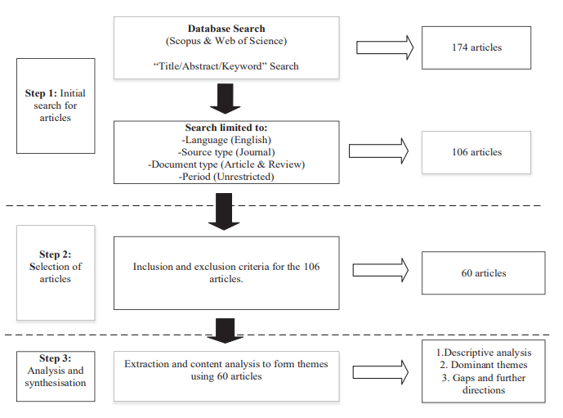
Source: Akomea-Frimpong et al. (2021)

Indent an equation 1 cm (or 10 spaces) from the left margin. Number it with an Arabic number enclosed in parentheses placed flush right. Allow one blank line above and one below each Equation. For example:
(1)

When referring to an equation in the text, write Eq. (1), except at the beginning of a sentence, where Equation (1) should be used.
Symbols should be italicized throughout the text. Define all symbols as they appear in the text. A nomenclature section is not necessary. All data, including those shown in tables and figures, must be reported in SI units.

Conclusion
The conclusion must briefly mention the study's limitations and recommendations for future research. Limitations in this context imply the research's limits/boundaries of applicability. For ongoing research, this may include the following stages of the research that will be conducted by the researcher to complete the investigation. Ideally, this section should demonstrate the contribution of the study and this paper (as summarized) and inspire other researchers to further develop the body of knowledge in the relevant field.

Acknowledgment
Authors may have to provide acknowledgment for any funding support they received for the research. Example: This study was financed in part by the Coordenação de Aperfeiçoamento de Pessoal de Nível Superior – Brasil (CAPES) – Finance Code 001.

References
Aznar, M., Pessoa, F.L.P. and Silva Telles, A. (1994), "Vapor-Liquid Equilibria of Mixed Solvent-Salt Systems using a MHV2 Model with the Wilson Equation", X Congresso Brasileiro de Engenharia Química, São Paulo, vol 1, 38-43.
de Freitas, G.C.S.; Peixoto, F.C.; Vianna Jr, A.S. (2008), Simulation of a thermal battery using Phoenics. Journal of Power Sources, 179, 424-429.
Duarte, C.S.A. (1999), Equilíbrio Líquido-Líquido em Sistemas contendo Polímero e Eletrólito: Água/ Polietileno-glicol/Fosfato, Laboratório de Equilíbrio de Fases, FEQ/UNICAMP, Campinas.
Fredenslund A. e Sorensen, J.M. (1993), “Group Contribution Estimation Methods”, in Models for Thermodynamic and Phase Equilibria Calculations, S.I. Sandler (ed.), Marcel Dekker, Inc., New York.
Silva, L.F. (2005), “Predição de Pontos Críticos de Misturas Termodinâmicas”, Tese de Doutorado, IPRJ/UERJ, Nova Friburgo.
Van Krevelen, D.W. (1990), "Properties of Polymers. Their Correlation with Chemical Structure, Their Numerical Estimation and Prediction from Additive Group Contribution", 3° ed., Elsevier, Amsterdam.

